
Florida Criminal Justice Executive Institute Associates, Inc.
7588 Anglewood Lane
Tallahassee, Florida 32309

November 5, 2012

Dear Graduate:

On behalf of the FCJEI Associates I would like to invite you to attend the 19th Annual FCJEIA Graduates Training Session. The Board of Directors has decided to hold this year’s training in Jacksonville. We will meet April 28- May 1, 2013 at the Crowne Plaza Jacksonville Riverfront; we have secured a room block for $99 a night. The hotel and area are ideal for family members who might accompany you. To make reservations call the hotel at 904-398-8800. This year’s topic is Leading Your Organization in Today’s Instant Information Environment, instructed by Lt. Colonel Jim Vance, USMC (Ret), Instructor, FBI Academy (RET).

There will be a welcome hospitality room open on Sunday April 28th with educational programs beginning at 8:00 a.m. Monday. The registration fee is $325.00 for graduates which include a one year membership and $350 for non-graduates. Also included in the registration fee is a lunch on Tuesday. There will be drawings for door prizes throughout the training. There will also be a prize awarded to the most represented class, so call and encourage your classmates to attend. Renew acquaintances, develop new contacts, and be part of a rewarding educational experience. Mark your calendars and make arrangements now to attend.

This training has also been approved for 20 hours of Sheriff’s Salary Supplement credit.

We are excited to be able to continue to offer the “Agency Registration Packages”; Send 3 people and the 3rd is half price; send 4 people and the 4th is free. Please inquire for further details.

More specific information will be sent at a later time; however, if you have any questions or need more information please feel free to contact any FCJEIA board member or Heather Desguin at 850-410-7828 or Terry Everest at 850-410-8646 in the Executive Institute.

Purchasing Agents: please note there has been a change of address for FCJEIA.
Checks should be made payable to FCJEIA, Inc.

I’m looking forward to seeing you in April!

Sincerely,
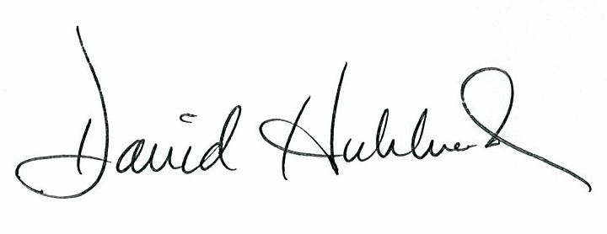
Dave Hubbard
President, FCJEIA

Enclosures

President
Dave Hubbard
Lieutenant
Eustis Police Dept.
(352) 483-5400

Second Vice President
Peyton C. Grinnell
Chief Deputy
Lake County S.O.
(352) 343-2101

Third Vice President
William M. Gladson
Assistant State Attorney
Fifth Judicial Circuit
Marion County
(352) 671-5800

Immediate Past President
Sean Jowell
Major
Pinellas County S.O.
(727) 582-6566

Exec. Secretary -Treasurer
Terry L. Everest
FCJEIA
fcjeiatreasurer@gmail.com

